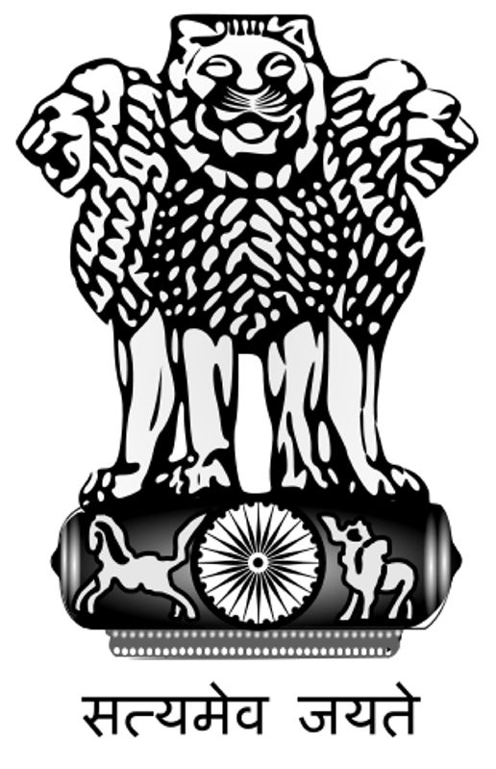

High Commission of India
Colombo
****

Vacancy for the Post of Office Executive:

High Commission of India in Colombo requires one Office Executive / Protocol Officer. Following are the details:

Job Description:
- Cross departmental co-ordination.
- Liaison with local authorities.
- Co-ordination of meetings.
- Handle all protocol matters.
- Airport facilitation of dignitaries.
- Liaison with Hotels.
- Any other work assigned.
Desired Candidate Profile:
- Graduate
- Proficient in English & Sinhala (Tamil will be added qualification).
- Strong communication & people skills.
- Good organizational & multi-tasking abilities.
- Good IT skills.
- Guest relations & problem solving skills.
- Ability to work for long hours with minimum supervision.
- Ability to solve impasses and remain calm in stressful situations
- Work experience of minimum 2 years in marketing / customer care / tourism.
- Age: Minimum-25 years and Maximum -35 years.
- Presentable & smart.

The eligible applicants who are in a position to join the High Commission immediately after the selection may apply. Applicants may send their CVs along with copy relevant documents to: admn2.colombo@mea.gov.in or Attaché (Administration), High Commission of India, 36-38 Galle Road, Colombo-03, on or before 17 March 2017. For any further queries please contact Mr.V.D.Mahto, Attaché (Administration) at 011-2336762.

