**Indian Cultural Centre**

**Colombo**

**Activities – September, 2014**

**10 September Film : Taare Zameen Par**

Indian Cultural Centre screened one of the most popular children film “Taare Zameen Par” directed by Aamir Khan at 3.00 pm on Friday 10 September 2014 at its auditorium. Around 60 guests attended the screening.

**12 September A Bharatha Natyam Duet by Ananya and**

**Apoorva S. Rao**

Indian Cultural Centre, Colombo organized a Bharatha Natyam Duet by Ananya and Apoorva from India at 6.00 pm on Friday, 12 September 2014 at its auditorium located at 16/2, Gregory’s Road, Colombo 07.

They commenced their performance with Pushpanjali and continued with Apadooru a Javali, Shiva Padam, Chaliye, Vishamakara Kannan and concluded with Dashavataram. The performance was very well received and appreciated by the audience. Around 75 guests attended the event.

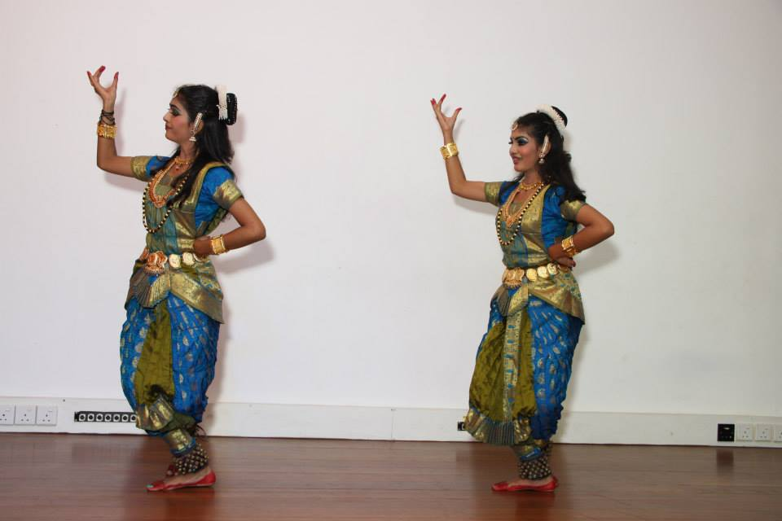

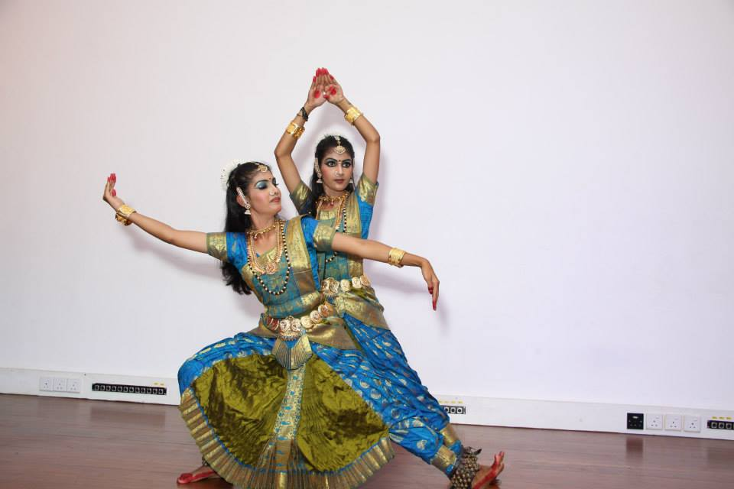

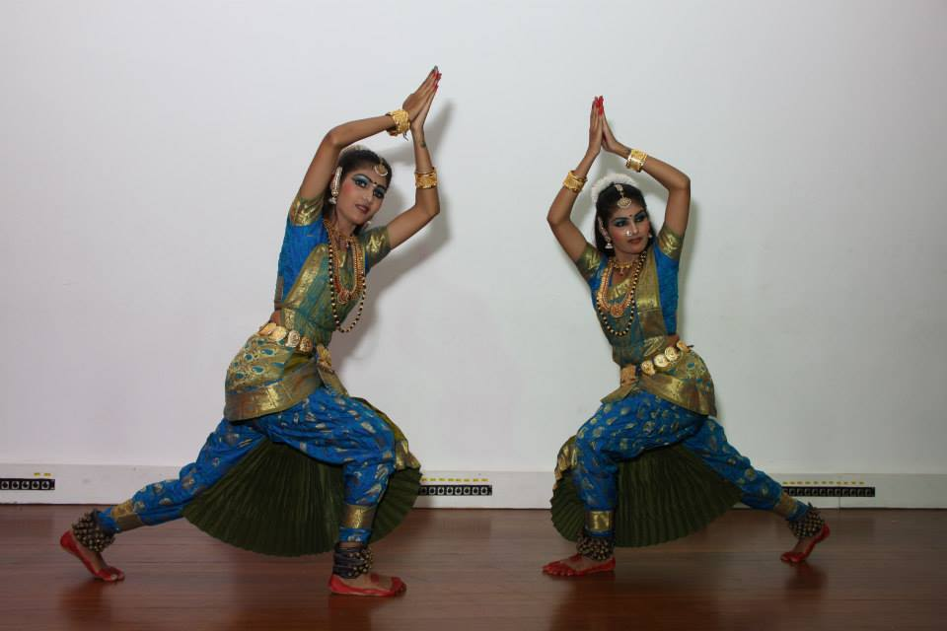

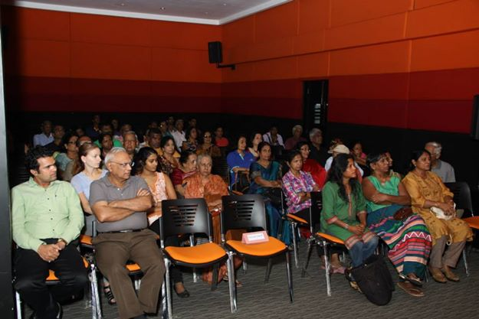

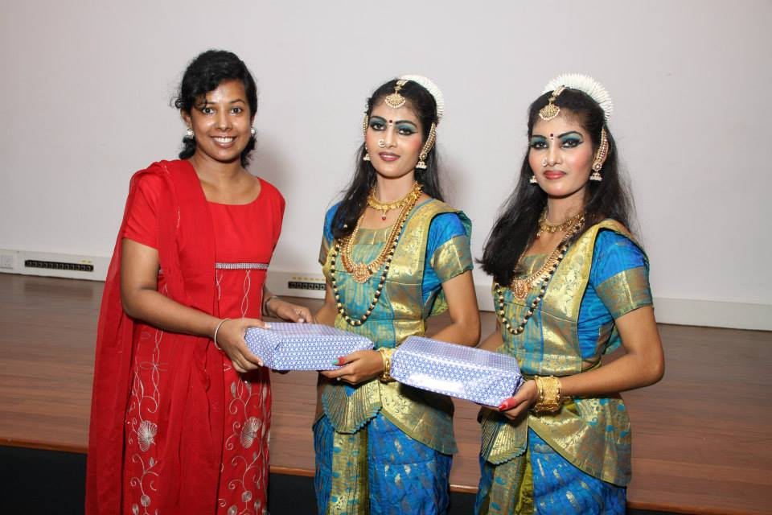

**15 September Hindi Diwas – A variety programme by the Hindi students of the Indian Cultural centre**

On 15th September 2014 Hindi Diwas was celebrated by the teachers and students of Indian Culture Centre, Colombo. Celebrating the occasion ICC organized many competitions such as speech, poetry recital and singing, dance, copy writing, rangloi, dictation and essay competition for its students.

The programme commenced with welcome speech by Ms. Shirin Qureshi followed by a speech by the Chief Guest Ms. Esha Srivastava, First Secretary (Press & Information), High Commission of India. She also presented the certificates to the winners of the competitions. Ms. Nadheera Shewanthi compeered the event. Ms. Shirin Qureshi delivered the vote of thanks.

The students of the Centre presented a colourful cultural performances included songs, skits, groups songs, group dance, instrumental performances etc., which was highly appreciated. Around 200 guests and students attended the event.

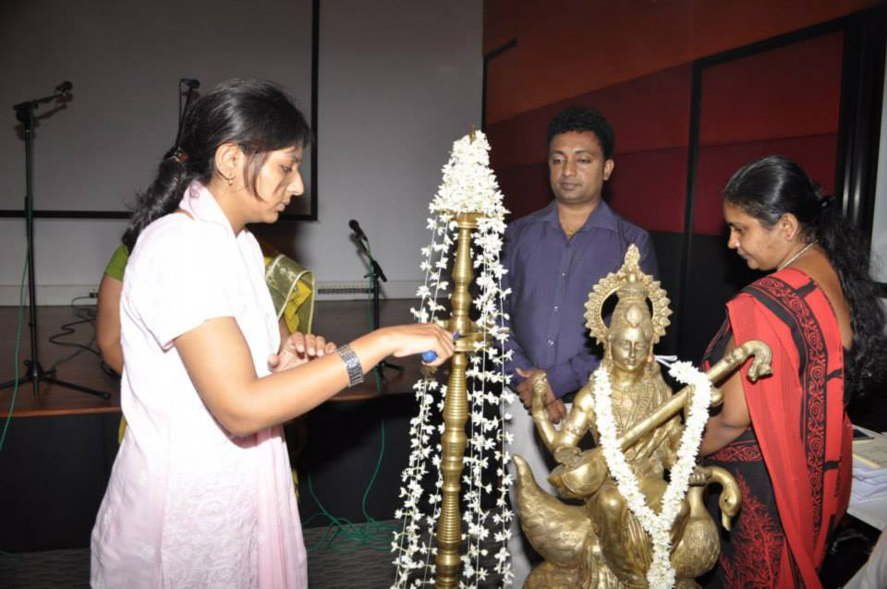

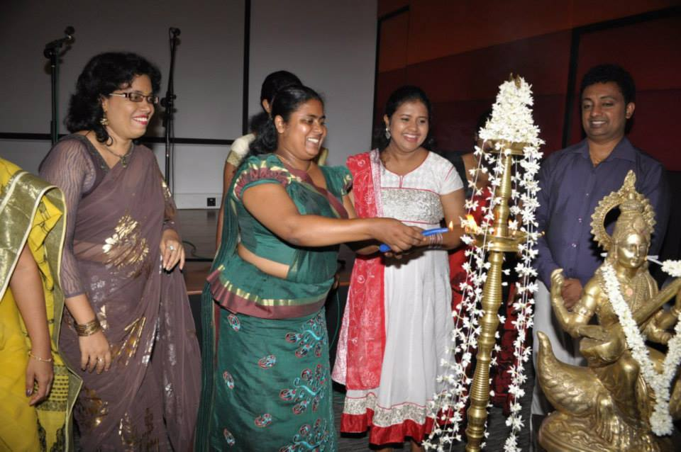

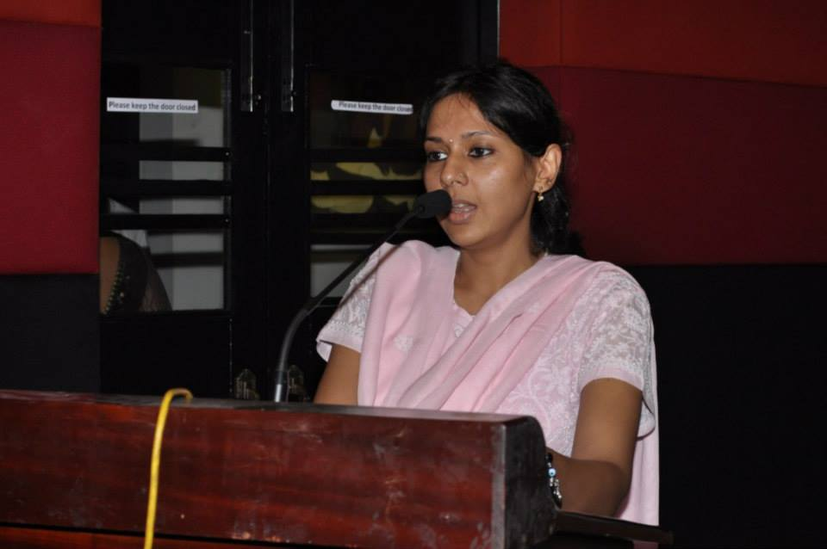

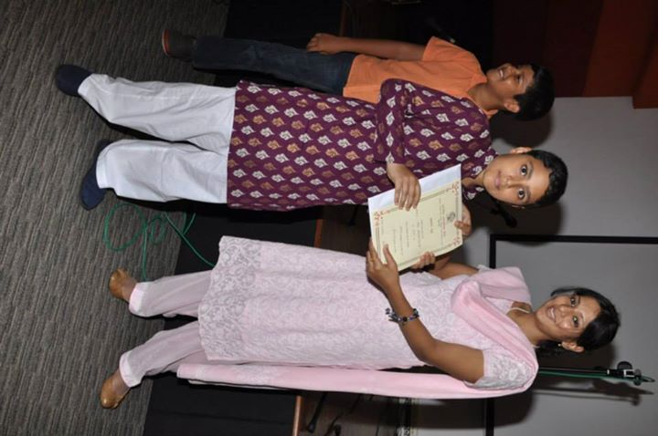

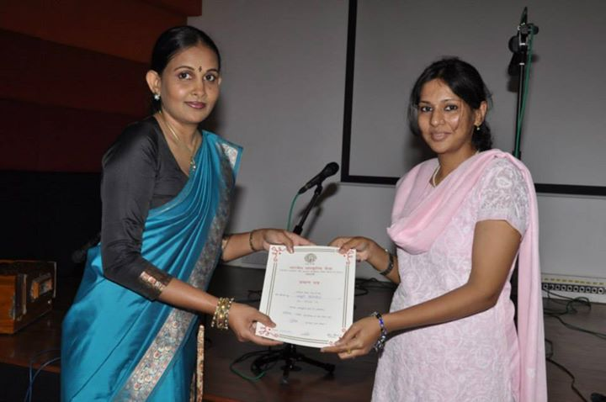

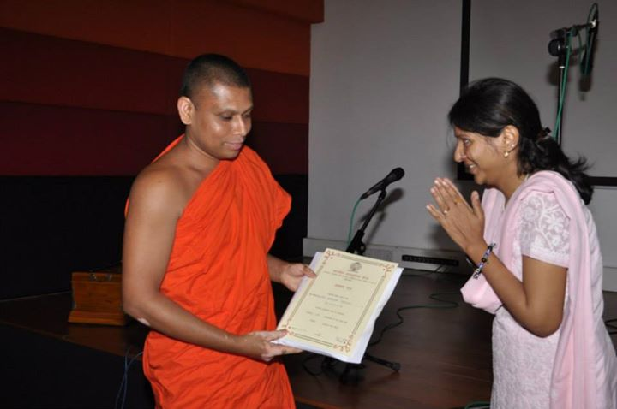

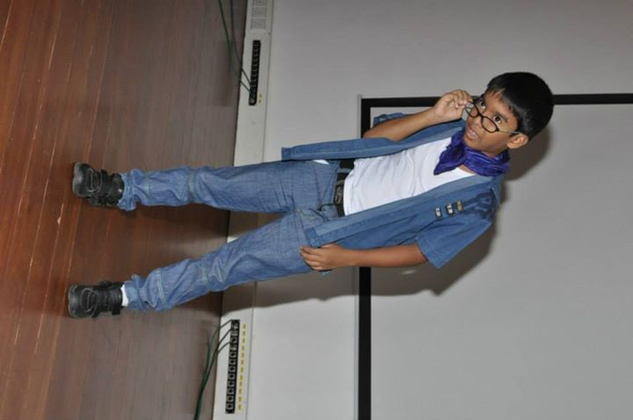

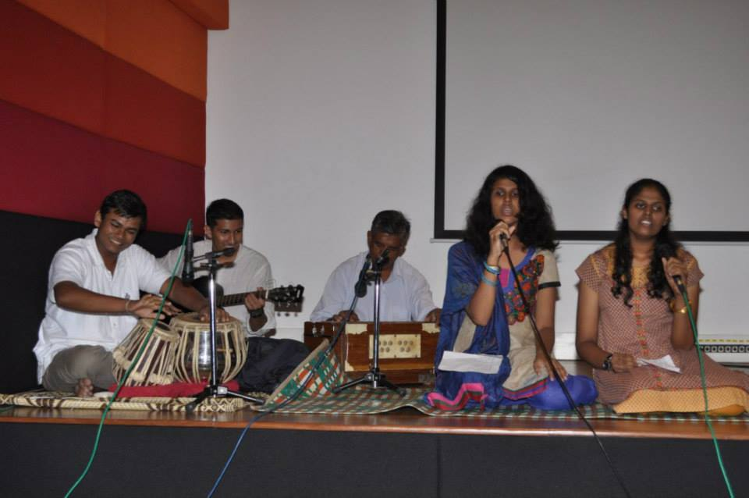

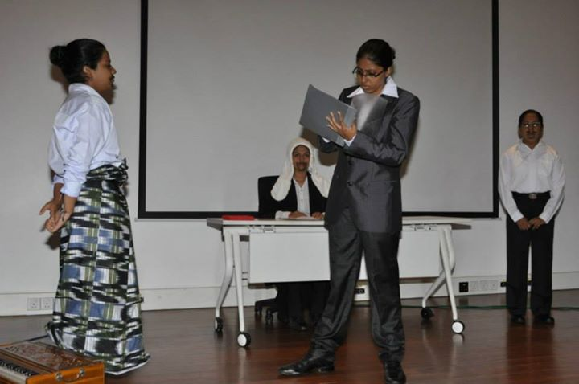

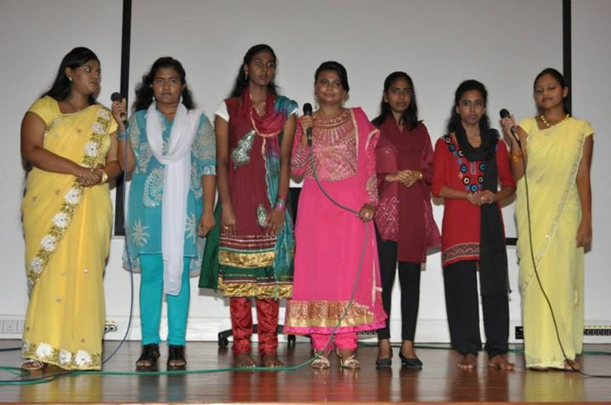

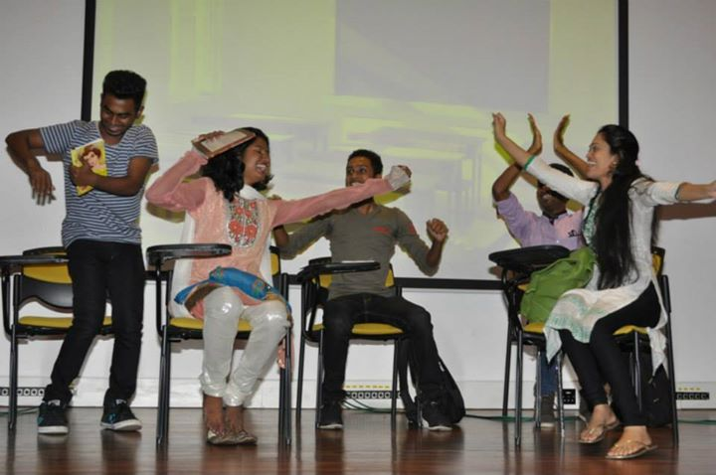

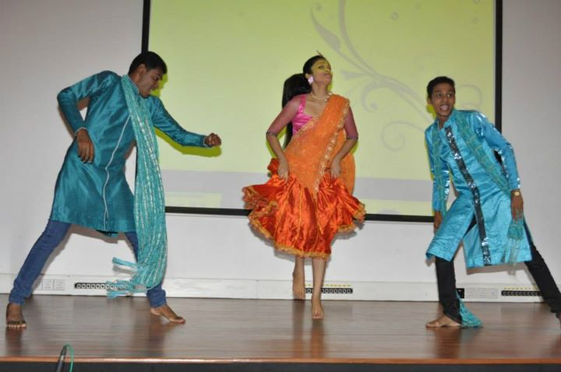

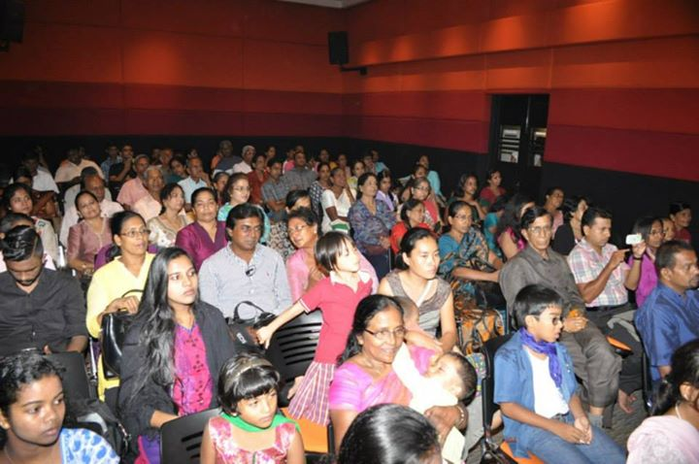

1. **September Friday matinee - Pinjar**

Indian Cultural Centre screened “Pinjar”. A film directed by Prakash Dwivedi and music by Uttam Singh at 3.00 pm on Friday 19 September 2014 at its auditorium.

The film was based on a Punjabi novel of the same name, written by Amrita Pritam. Urmila Matondkar, Manoj Bajpai and Sanjay Suri are in the lead roles. Around 50 guests attended the screening.

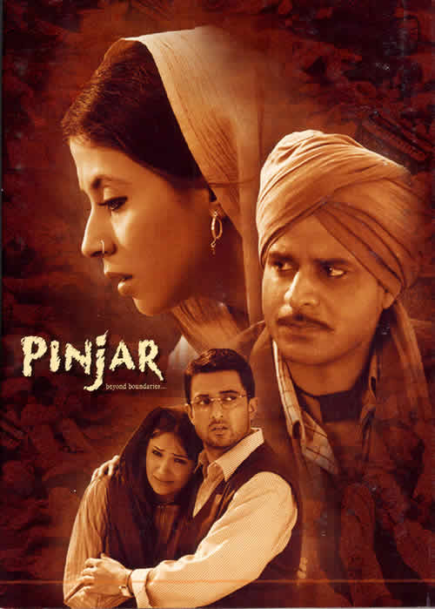

1. **September Biryani – Cookery Demonstration by Shefali Nagar**

**Vasanji**

An enthusiastic audience gathered at the Centre to witness the expert skill of the Ms. Shefali Nagar Vasanji of the Mithi Mirchi turn out the mouth watering Indian cuisine. The items prepared were vegetable dum biryani, beetroot biryani, chicken biryani, capsicum onion salad, carrot cucumber raita, panna and mixed fruit cream. The audience was given clear instructions on the preparation of each recipe and they were treated to a sample of the preparations. Around 75 guests attended the demonstration.

